**Data Engineering Assignment - 24**

**Devops Git Integration**

Copying the link address to clone the repository in local.

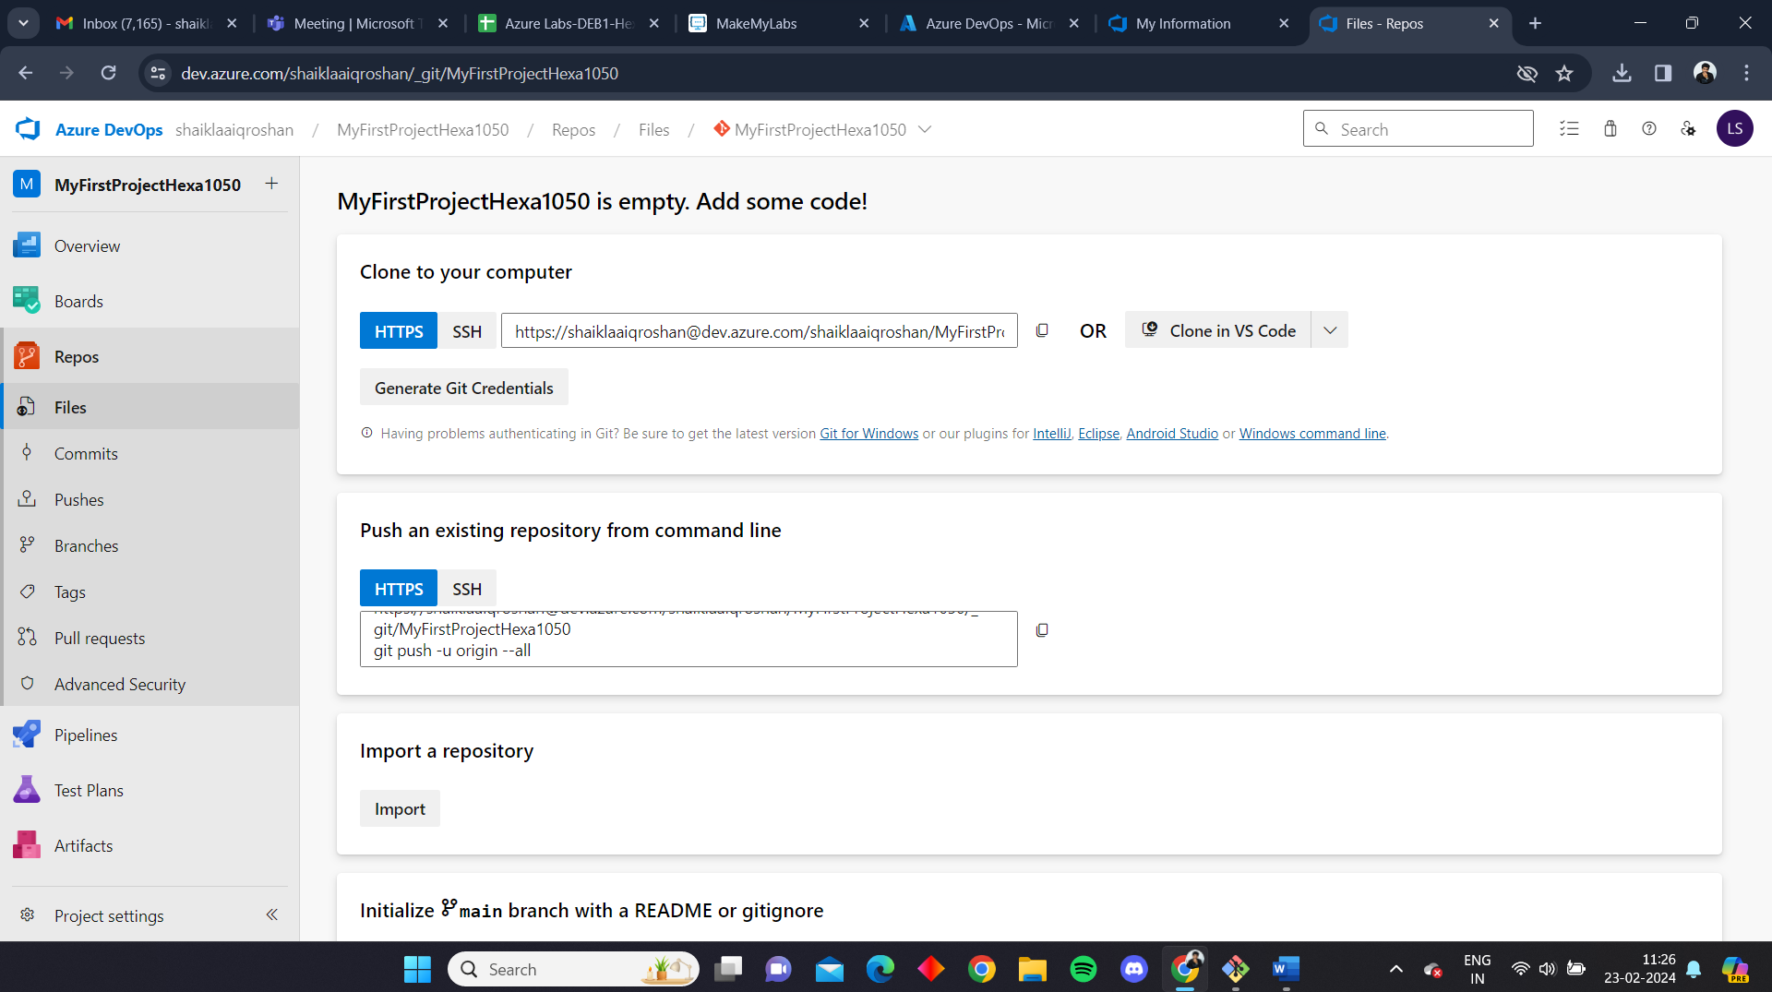

Run the git clone command along with the copied URL.

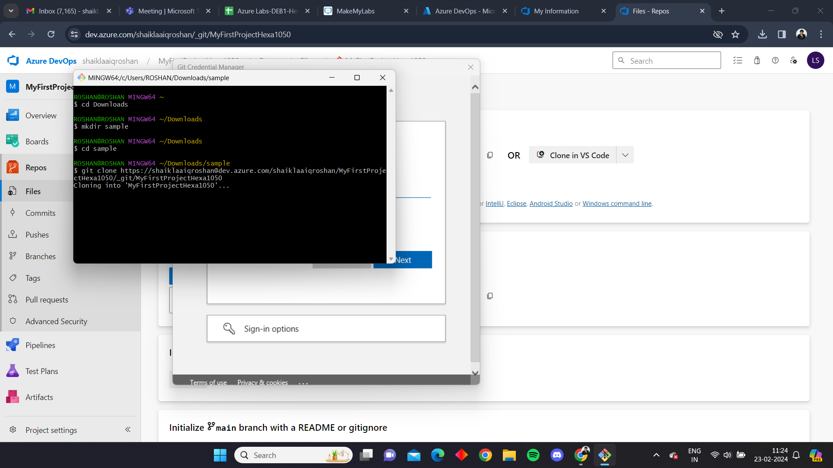

We can see the empty repository has been created in local

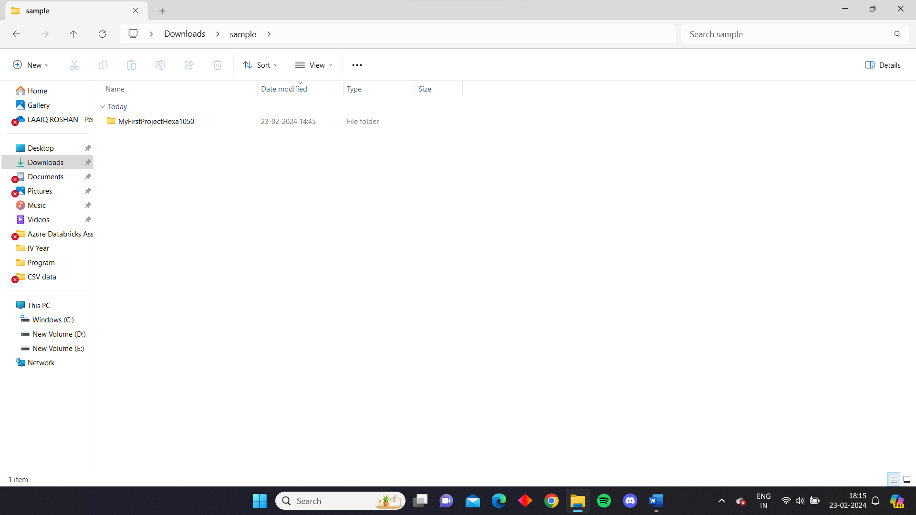

Now to perform push operation we added a sample.docx file in the local repo and added the file to the stagged area then performed commit and pushed it to the repository

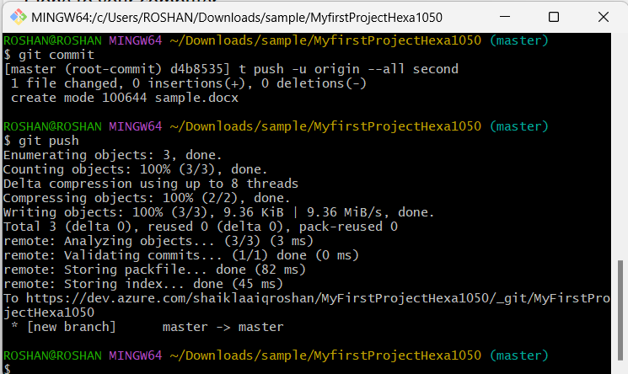

While pushing we have to give our credentials to the git for security reasons

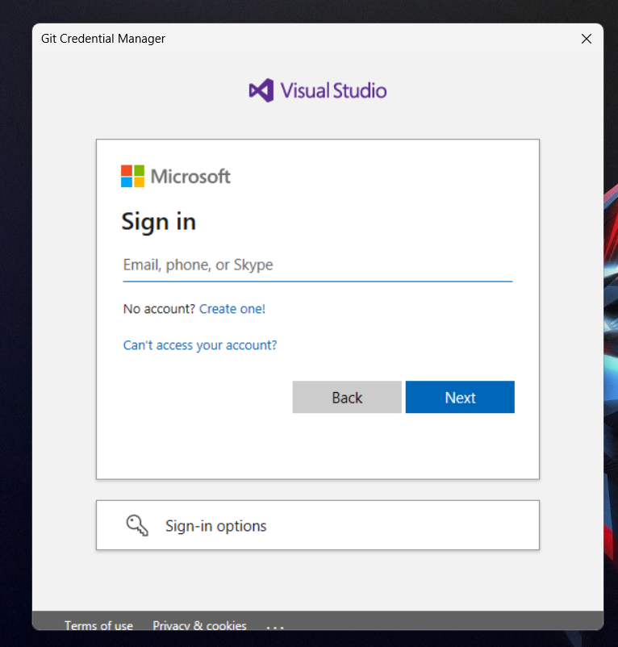

We can see the sample file is present in the repository

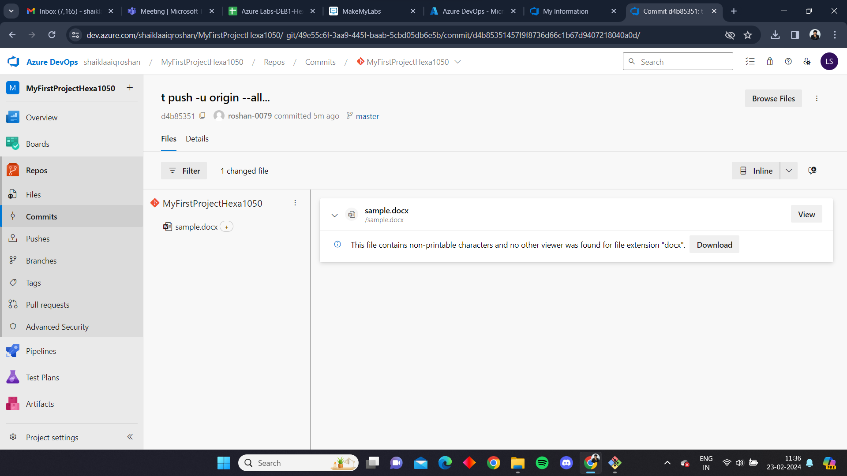

Now to perform pull operation we added a file named new in the repository, this file has been pulled into the local repository by using the git pull command.

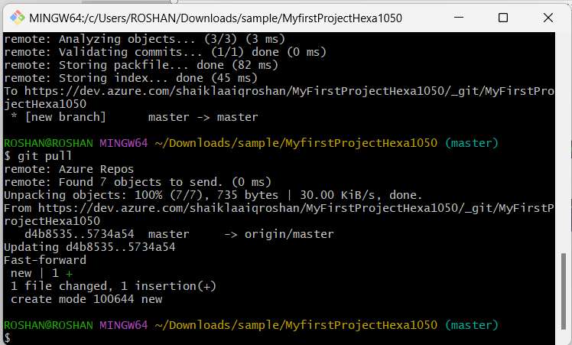

Now we can see the clone of the repository in local, here the git folder has been created by the time of the creation of repository, sample has been pushed from local to repository and new has been pulled from the repository into the local, hence performing the push and pull operations.

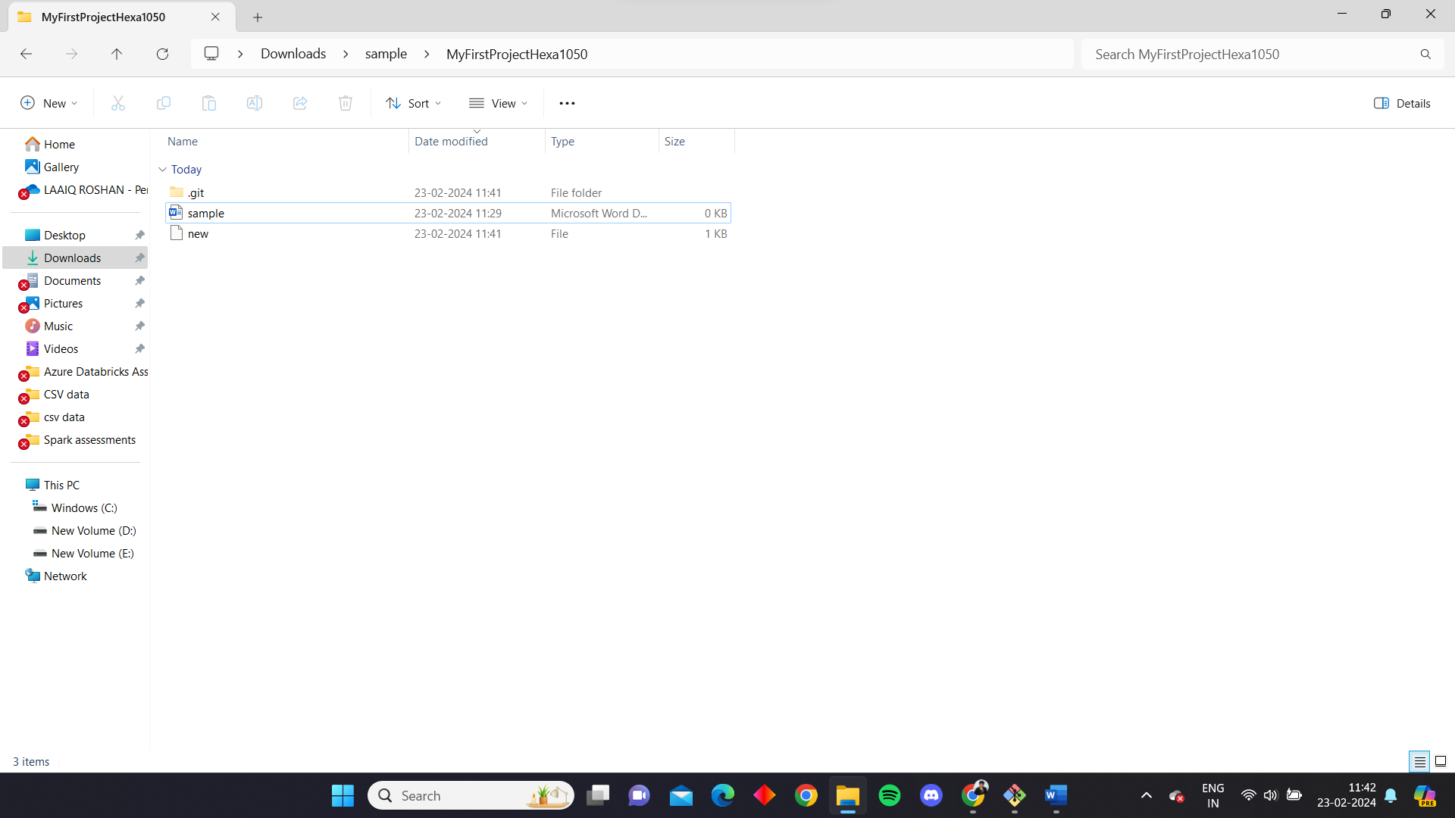

We can also see the history of commits in the repo.

